**Department of Computer Science and Engineering**

|  |  |
| --- | --- |
| **Course Code:CSE260** | **Credits: 1.5** |
| **Course Name: Digital Logic Design** | **Semester: Fall’18** |

**Lab 09  
Designing Sequential Circuit from State Diagram Using T Flip-flops**

1. **Topic Overview:**

The students will get acquainted with the idea of sequential circuits for the first time through this experiment. They will explore the key steps to build a digital sequential circuit from a given state diagram using T Flip-flops as well.

1. **Lesson Fit:**

A clear understanding on combinational circuits as well as some introductory knowledge about sequential circuits especially concepts about flip-flops, clocking mechanisms are prerequisite for this lab.

1. **Learning Outcome:**After this lecture, the students will be able to:
   1. Gain hands on experience of the components of a sequential circuits e.g. flip-flops, clocks etc.
   2. Explore the steps to derive state equations for flip-flops from a state diagram.
   3. Learn to use a JK flip-flop as a T flip-flop.
   4. Understand the pin diagram of IC 7476.
2. **Anticipated Challenges and Possible Solutions**
   1. Students might find it difficult about how state diagrams work.

**Solutions:** Instructor will explain how clock pulse triggers state transitions from one to another.

* 1. Students might struggle understand the significance of PR & CLR pins & thus the might forget to connect them to the appropriate ports.  
     **Solution:** PR is known as preset or set pin which sets the value of the output pin to **high** whereas CLR means clear pin which forces the value of the output pin to **low**. Both of them are active low. So to enable preset & clear bit respectively each of them must be set to **low** respectively. And to disable them, each of them must be set **high**.

1. **Acceptance and Evaluation**

Students will show their progress as they complete each step of the problem. They will be marked according to their lab performance. Students have to show the outputs of both the problems from the constructed circuit otherwise full marks will not be given.

1. **Activity Detail**
   1. **Hour: 0.0 - 1.5   
      Discussion:**Explain what sequential circuits are & why they are important & different than the combinational circuits taught so far. Discuss about how flip-flop serve its purpose in making a sequential circuits & some related concepts like clocks, edge triggering etc. Then discuss steps to derive state equations from the state diagrams using properties of T Flip-flops & Truth Table.

|  |  |  |
| --- | --- | --- |
| **Table 1: Truth table of T Flip Flop** | | |
| T | Q (Current State) | Q+ (Next State) |
| 0 | 0 | 0 |
| 0 | 1 | 1 |
| 1 | 0 | 1 |
| 1 | 1 | 0 |

**Table 2: Truth table of the given state diagram using T Flip-Flop**

|  |  |  |  |  |  |  |
| --- | --- | --- | --- | --- | --- | --- |
| Current State | | Input | Next State | | Input to the T FF to implement the state diagram | |
| A | B | X | A+ | B+ | TA | TB |
| 0 | 0 | 0 | 0 | 0 | 0 | 0 |
| 0 | 0 | 1 | 0 | 1 | 0 | 1 |
| 0 | 1 | 0 | 1 | 0 | 1 | 1 |
| 0 | 1 | 1 | 0 | 1 | 0 | 0 |
| 1 | 0 | 0 | 1 | 0 | 0 | 0 |
| 1 | 0 | 1 | 1 | 1 | 0 | 1 |
| 1 | 1 | 0 | 1 | 1 | 0 | 0 |
| 1 | 1 | 1 | 0 | 0 | 1 | 1 |

**IC 7476 Pin Diagram**

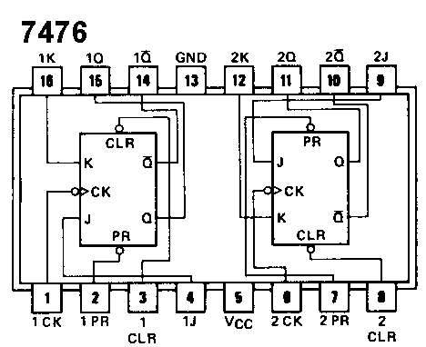

**Problem Task:**

Derivation of state equations of Task 1.

* 1. **Hour: 1.5 - 3.0**

**Discussion:**

Check the state equations from activity (a) . After checking the equations, ask them to construct the Circuit.  
  
**Problem Task:**Construct the circuit state equations from Task 1 on the trainer board of AT-700.

* 1. **Hour: 2.5 - 3.0**

**Discussion:** Check their progress in implementation.

1. **Home tasks:**

As a part of their home tasks students need to submit a lab report covering the followings

1. Name of the Experiment
2. Objective
3. Theory
4. Required Components and Equipment
5. Experimental Setup (No need to draw the IC configurations)
6. Experimental Result and Discussions.

**Lab09 Activity List**

**Task 1:**

Design a sequential circuit for the following state diagram with T flip-flops:

00

10

11

0

0

0

0

1

1

1

1

01

**Circuit Connections:**

**IC 7476 (JK Flip-flop):**

* + **Short** J & K pin to make it T Flip-flop.
  + **Pin 2 & 7:** **Set** them to **High (1)** always. (Connect with VCC).
  + **Pin 3 & 8:** **Set** them to **low (0)** at first (connect with GND from the board) & then **set** to **High (1)**. (Connect with VCC)
  + $X$ comes from the input.
  + $TA = A^{'}Bx^{'}+ABx [2J=2K]$ [Short]
  + $TB=B^{'}x+Ax+A^{'}Bx^{'}\left[1J=1K\right]$ [Short]
  + $[1CK=2CK]$ [Short] clock pulse input [Falling edge]
  + Connect $1Q=B, 2Q=A$ to LED.

$TA \& TB$ are obtained from **Table 2.**